Bus Booking System

Submitted By

Student Name---------- Department of Computer Science
University Roll No. ------------- Takshshila, Jabalpur (M.P.)

Student Name--------- Department of Computer Science
University Roll No. ------------- Takshshila, Jabalpur (M.P.)

Student Name--------- Department of Computer Science
University Roll No. ------------- Takshshila, Jabalpur (M.P.)

Paper Code: PCCCS483
Paper Name: Object Oriented Programming Using Java

Department of Computer Science
Takshshila, Jabalpur (M.P.)

Takshshila Institute of Engineering & Technology
Sharda Mandir Road, Sharda Chowk, Madan Mahal,
Jabalpur, Madhya Pradesh 482001

TABLE OF CONTENTS

ABSTRACT.................................................................................... 03

CHAPTER – 1 : INTRODUCTION
  - Introduction …………………………………………… 04

CHAPTER – 2 : PROBLEM STATEMENT
2.1 Problem Statement .......................................................... 05
2.2 Motivation ........................................................................ 06
2.3 Objective …....................................................................... 06

CHAPTER – 3: PROPOSED SOLUTION & RESULT ANALYSIS
3.1 Methodology Used ............................................................. 07
3.2 Database & Tables ............................................................. 09
3.3 Results & Reports .............................................................. 11

CHAPTER – 4: CONCLUSION & FUTURE SCOPE
4.1 Conclusion .......................................................................... 12
4.2 Future Scope ...................................................................... 12
CHAPTER – 5: BIBLIOGRAPHY .................................................. 13

Abstract :-

Bus Booking System is a system that maintains the information about the booking bus tickets, Username which is travel in the bus, bus details, select destination, select date of journey, book tickets and see summery of booking ticket.
This is difficult to organize manually. Maintenance of all this information manually is a complex task and risky too. It may be possible that things may go wrong while doing data entry or keep the record update and that can lead to a great loss.
Bus Booking System is a project which aims in developing a computerized system to maintain all the daily work of bus booking.
This project has many features like :-
1. Add Username
2. Add Destination From to To
3. Add Bus Number
4. Select Journey Date and Time
5. Book Ticket with Payment
6. See Summery of Booking

This project is developed to help transport members in a best possible way and to help them un maintaining the records of the bus booking more effectively.

Chapter 1

INTRODUCTION

  - Introduction

The Bus Booking System in Java is a user-friendly application that replicates real-world online ticket booking systems for buses.
Users can select destinations, travel dates, preferred buses, and available seats. Upon selecting, the system calculates fare, generates a ticket with a unique ID, and simulates saving or printing the ticket. Admins can manage bus schedules, fare details, and seat capacity.
The GUI interface enhances usability with dropdown menus, calendars for date selection, and real-time seat availability.
This project is ideal for transport agencies, private operators, or academic use to demonstrate real-world application development involving file handling, GUI interaction, and object-oriented programming.

Chapter 2

PROBLEM STATEMENT

3.1 Problem Statement

In the present generation, where for every work to be done we are dependent on the computers and the software we were still maintaining our booking system whether in Road transport, Airlines, Railways i.e. maintaining each and every record manually, using paper files to maintain the entries of the booking by transport members. which was becoming very hectic and difficult to maintain such a large database records of everything. That’s why there was a need of a simplified solution from where one can manage all the records of the transports much easily and effectively without the loss of any data or a record. Here comes a simplified solution of using a Bus Booking System software to increase and simplify the work.

3.2 Motivation

Transports are giving citizens facilities to travel one place to another place. In digital times they are needed more than ever before. In our country, the records of the transport system are maintained by using paper files which causes great loss to environment as cutting down of millions of trees for the sake of making papers is not a sustainable solution to maintain the records. For the sake of our environment, we take this step (Bus Booking System Software) to reduce the cutting down of trees.

3.3 Objective

The aim of this project is to develop a system that can handle and manage the activities involved in a transport in an easy way. Less managing personnel and easy maintenance of database.

- Develop a system that can replace the manual bus booking file entry.

- Maintain passenger and bus records securely.

- Provide real-time seat availability.

- Create an easy to understand user friendly environment

- Generate booking receipts and reports summary.

Purpose :-
The system is intended for small to medium transport services, focusing on user-friendly booking and efficient data handling.

Scope :-
To design and implement a computerized bus booking system that simplifies ticket reservations, cancellations, and schedule management.

Chapter 4

PROPOSED SOLUTION & RESULT ANALYSIS

4.1 Methodology Used
This project is made using Java Swing in Intellij IDEA with the database MySQL. With the help of Java Swing technology, the frontend part of the application is made and then we have used the JDBC Driver to connect it with the database that was made using MySQL.

1. Java Swing :- Swing is a GUI widget toolkit for Java. It is part of Oracle's Java Foundation Classes – an API for providing a graphical user interface for Java programs. Swing was developed to provide a more sophisticated set of GUI components than the earlier Abstract Window Toolkit.

2. MySQL Database :- MySQL is an open-source relational database management system. A relational database organizes data into one or more data tables in which data types may be related to each other; these relations help structure the data. SQL is a language programmers use to create, modify and extract data from the relational database, as well as control user access to the database.

3. JDBC Driver :- JDBC provides an interface which allows you to perform SQL operations independently of the instance of the used database. To use JDBC, you require the database specific implementation of the JDBC driver.

4. MySQL Connector :- A jar file is a collection of Java classes (usually a library). ... jar is version 8.0. 12 of the MySQL Connector/J JDBC driver. A JDBC driver is used to connect to a database, in this case to MySQL.

5. JCalender :- JCalendar allows you to choose a year, a month and a day. Depending on the locale, the month names and the weekday names change. The foreground of “today” is painted red. JCalendar is composed of several other beans described below.

Entity-Relationship (E-R) Diagram
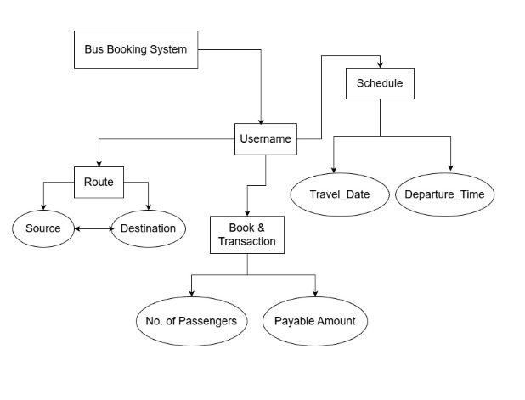

4.2 Database & Tables
MySQL is an open-source relational database management system. A relational database organizes data into one or more data tables in which data types may be related to each other; these relations help structure the data. SQL is a language programmers use to create, modify and extract data from the relational database, as well as control user access to the database.

How to connect Java Application with Database using JDBC Driver?
Code Snippet :-
package bus booking system;

import java.sql.*;

public class Connect {
Connection c;
Statement s;

public Conn() {
try {
Class.forName("com.mysql.cj.jdbc.Driver");
c = DriverManager.getConnection("jdbc:mysql:///bus_booking_system_2026","*****","******");
s = c.createStatement();

} catch(Exception e) {
System.out.println(e);
}
}

}

Tables and their Code Snippets :-

1. Booking_Detail Table :- In this table, all the necessary information related to booking bus ticket with that user details like user_name, s_source, destination, no_of_passenger, bus_time, journey_date, paid_amt are stored so that the user can manage all the records of the booking.
Snippet :-
Create table booking_detail(user_name varchar(50), s_source varchar(60), destination varchar(60), no_of_passenger varchar(60), bus_time varchar(60), journey_date varchar(60), paid_amt varchar(60);

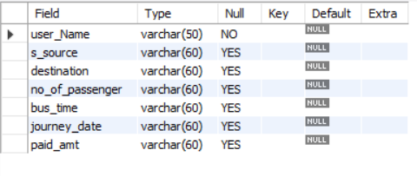

4.3 Results & Reports

1. Welcome Bus Booking System Page

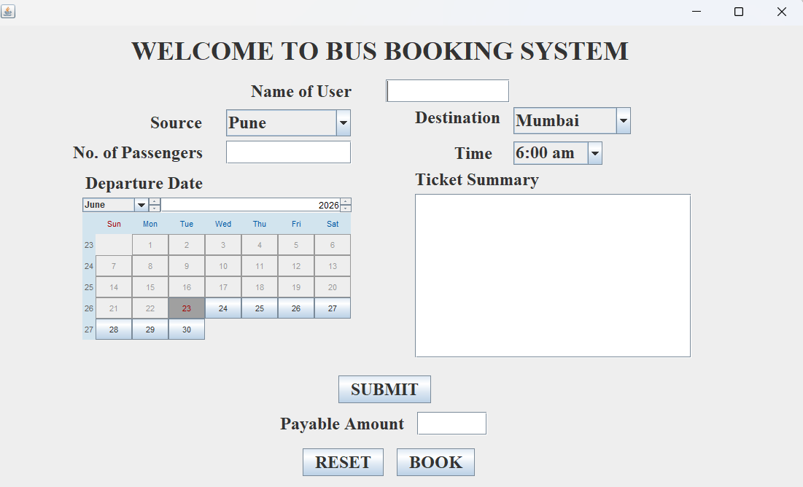

Chapter 5

CONCLUSION & FUTURE SCOPE

5.1 Conclusion
In this Bus Booking Application, we have various features that typically we have to do it manually. It has features like User Details, Bus Detail, Booking Detail etc in which we get info about user which is booking tickets. It also stores User information such as name, source to destination, travel date and time, payment receipt, which will help admin to maintain the records and tracks of all the passenger regarding their booking when booking and cancellation.

  - Future Scope

- We can make this as Server based Application

- We can also make this as an Android and IOS application

- We can make this application open for all over the world

- We can also upload some pdfs or notes in this application so that students can access the resources remotely too.

Chapter 6

BIBLIOGRAPHY

References:-
- https://www.jetbrains.com/idea/
- https://www.mysql.com/downloads/
- https://dev.mysql.com/downloads/connector/j/
- https://www.javatpoint.com/java-swing
- https://www.mysql.com/products/connector/
- https://toedter.com/jcalendar/
- http://www.java2s.com/Code/Jar/j/Downloadjcalendar14jar.htm
For complete source code of the Project :-
- https://github.com/narayandeep020/java_swing_project_2026/bus_booking_system_2026

